# IU verse



Figure . Midnight walk.

* [Midnight Walk](https://music.youtube.com/watch?v=CgGJlSvA9m4&si=t5RT4pkICdpIR2-z)



IU is so sweet!

* [They are sweet. I'll hook Park Go Bum with Jasmin. Maggie is beyond high maintenance.](https://x.com/_IUofficial/status/1903355975853302131)
* [Promotional tour](https://x.com/dlwlrma_08918/status/1903355106848059875)

# AOC and Tim Waltz

* [Nerd!](https://x.com/PBDsPodcast/status/1903240621940412815)

I asked Alfred from Six Flags, “What is a true definitely of a turn-off?”

“What?”

“Finding out Deanna is a Thai boy”.

* [Holy S. AOC is ready to fight with/for Kamala!!!](https://x.com/AOC/status/1903279755916611743)

# Nvidia

Nvidia’s AI Model

* [Nvidia's AI Model](https://www.msn.com/en-us/money/other/nvidia-unveils-physical-ai-models/vi-AA1BfT1s?ocid=socialshare&pc=DCTS&cvid=728d5b4bad694664a6f315854fbf6113&ei=10)

# WeBank Chairman

* Chairman of [WeBank, David Ku, talks to the members at Project Melo about the future of banking.](https://www.linkedin.com/posts/issihkcom_ndvncjjbtkqf-businessdigest-business-activity-7178150387261091845-urmT?utm_source=share&utm_medium=member_desktop&rcm=ACoAAFLlH_IBCiMv7cpJu6D64RljTHRL6E8WPIk)

# Fact versus Fiction

* [Fake titties](https://x.com/ChrisWillx/status/1903129895640928603)

# Email Sender

|  |
| --- |
| @StuartMcMillan1 from Mark Andreesen |
| @michaelpollan from Chris Williamson |

@YGBABYMONSTER_ for SirrusXM

from The View

@JohnLeguizamo

@billburr

@davidblaine

@SenSchumer

# Compiling $PTD Modules from the start

Synopsys

Plastic Tornado Distribution is a package that contains the sources for KMP, StarShip, PepMan, and MultiPlatform. While KMP is a Dynamic Web Service for Tomcat and requires multiple steps in compiling the sources to the war file, the remaining three modules is straight forward. This document outlines the steps required to compile the three Java Applications: StarShip, PepMan, and MultiPlatfrom from the start.

Alternatively, you can go to the $PTD/docs/install/ and double-click on PepMan.jar, StarShip.jar, and Multi-Platform to run the Java Applications.

Step 1:

Unzip the Plastic Tornado Distribution. We can call it C:\eclipse-workspace\PTD.

Step 2:

Select that directory we had just created from Eclipse upon starting up the development environment. You will be prompt to select the working directory as shown:

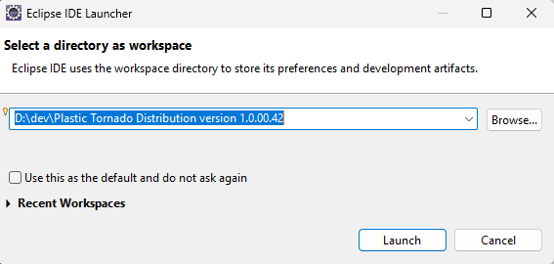

Figure . Select the working directory as the unzip directory.

Step 3:

Create a new Java Project by selecting the PepMan/ as the module directory.

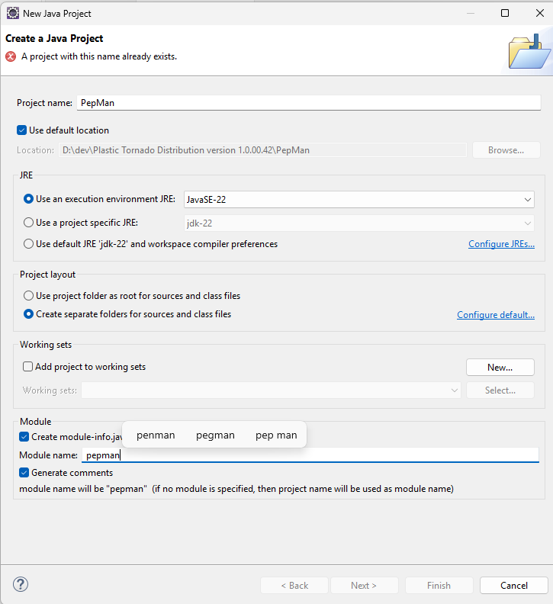

Step 4:

Fix the module information by adding “requires desktop” option in module-info.java.

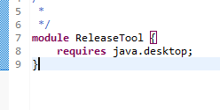

Figure . Add the "java.desktop" option to the module-info.java file.

Step 5:

Import the required javax.* library by right-clicking on the red import error.

Step 6:

The final step to compile can proceed if there are not more “red highlighted” error.

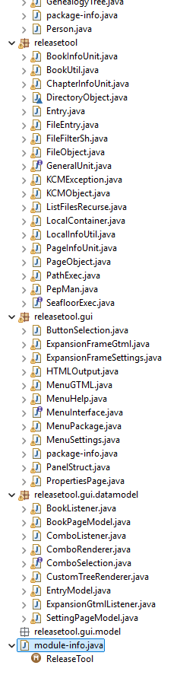

Figure . No more red highlighted error.

If the “Build All” option is grey out, then it is good to run or to be debugged.

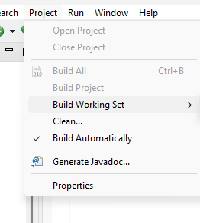

Figure . You are good to compile.

# I am hungry

Seriously need to take advise from Joe Biden: stick with their daytime job.

* [Fud (from the farside)](https://x.com/elonmusk/status/1902824994809278711)

# Severance

* [Ben Stiller makes the ask](https://x.com/tim_cook/status/1903054357924549015)

# Rose

* [Rose is pronounced Ro-say just like JCPenney is pronounced JCPenny-ay.](https://x.com/roseannepics/status/1903067120587456678)